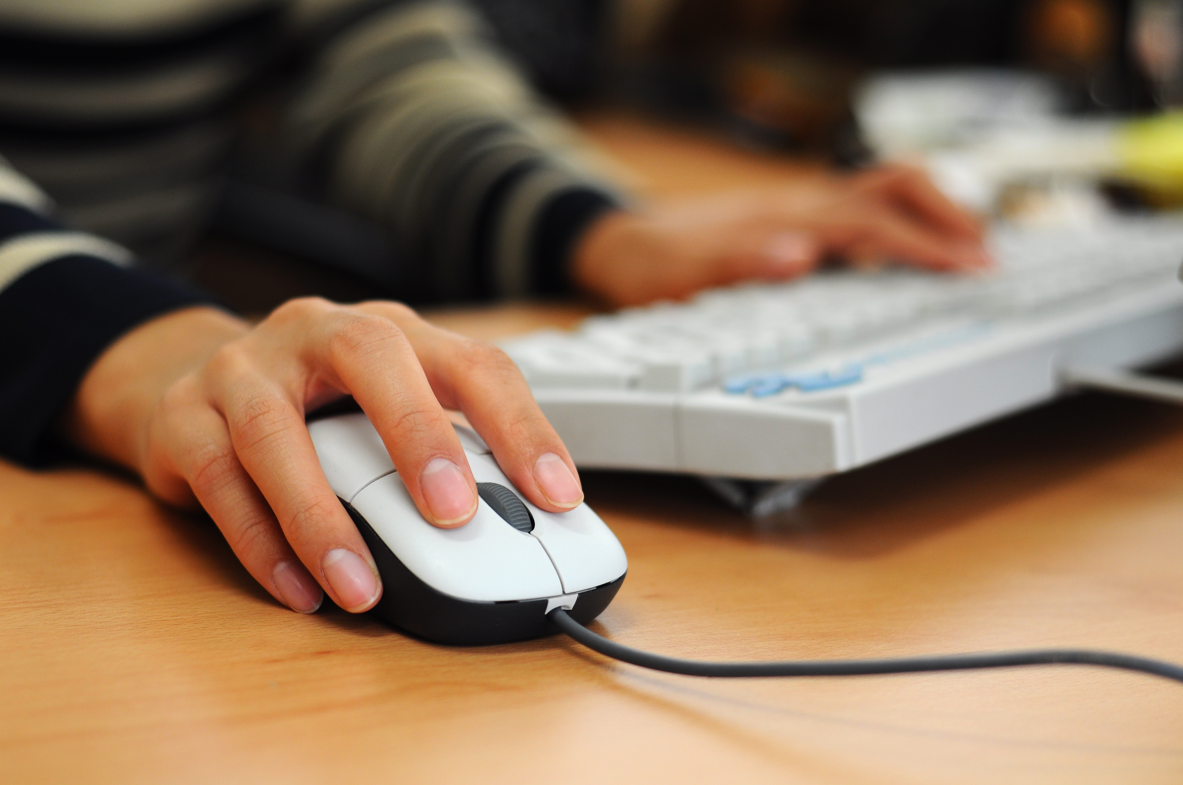
Future Development

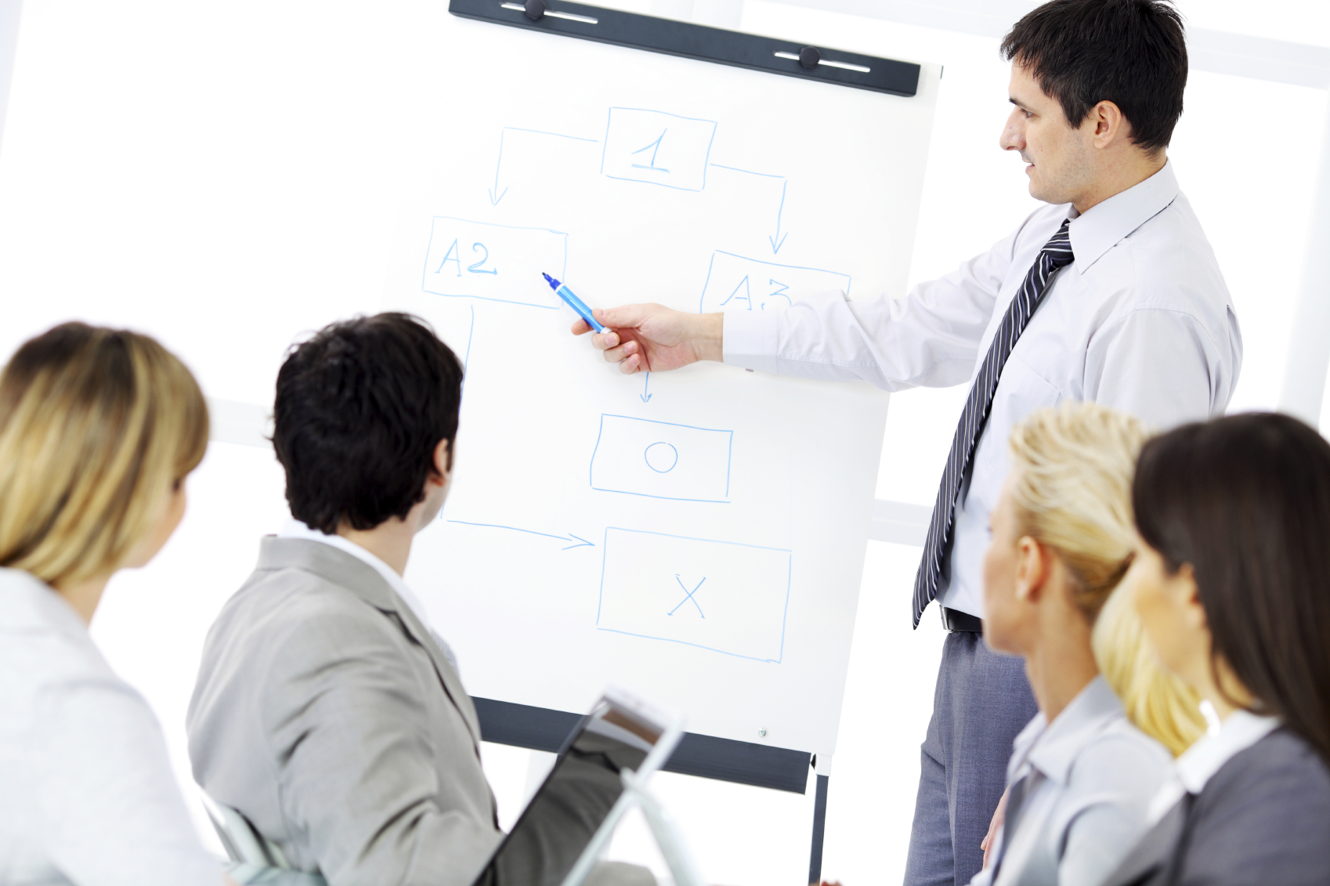

The Prototype
At this point in development, we have a prototype of the final product. The Prototype acts as a ‘Proof of Concept’ and is presented to our client as a preview of what the final product will be able to do.

We achieved this by creating a ‘dummy’ piece of software that was able to search through a small number of documents and demonstrated the features that will be present in the final build.

Once the prototype was created we presented it to our client, the LACR team. When the client was happy with our software we were then ready to begin work on the final product.

Expanding the Prototype
To produce the final piece of software we plan on expanding the prototype to ensure the requirements outlined by the client are met. The requirements the software will meet include:

Allow users to search through all stored documents/images
We will achieve this by ensuring the software is able to search through all of the documents given by the LACR team as well as the corresponding images of the documents.

Allow users to download documents/images/XML files
This will be achieved by ensuring the software allows users to download the files that we have stored. They will be able to download the documents, images of the documents and the XML files that are used in the searching process straight onto their system.

Allow a user to sign in as an administrator and gain various privileges
The software will have two types of users. The general public and also the LACR team themselves. Because of these two user groups, we plan to allow certain privileges to the LACR team by implementing a sign-in feature that allows LACR team members to sign in and perform additional tasks.

Allow administrators to upload and delete documents/images
We plan to allow Admins to both upload and delete documents stored by the however, further permissions may be implemented per the clients' request.

Hardware
Our Prototype, in its current, state is being stored online using a ‘Cloud-based’ storage device. While this is satisfactory for our prototype. we plan on hosting the final piece of software on a physical server.
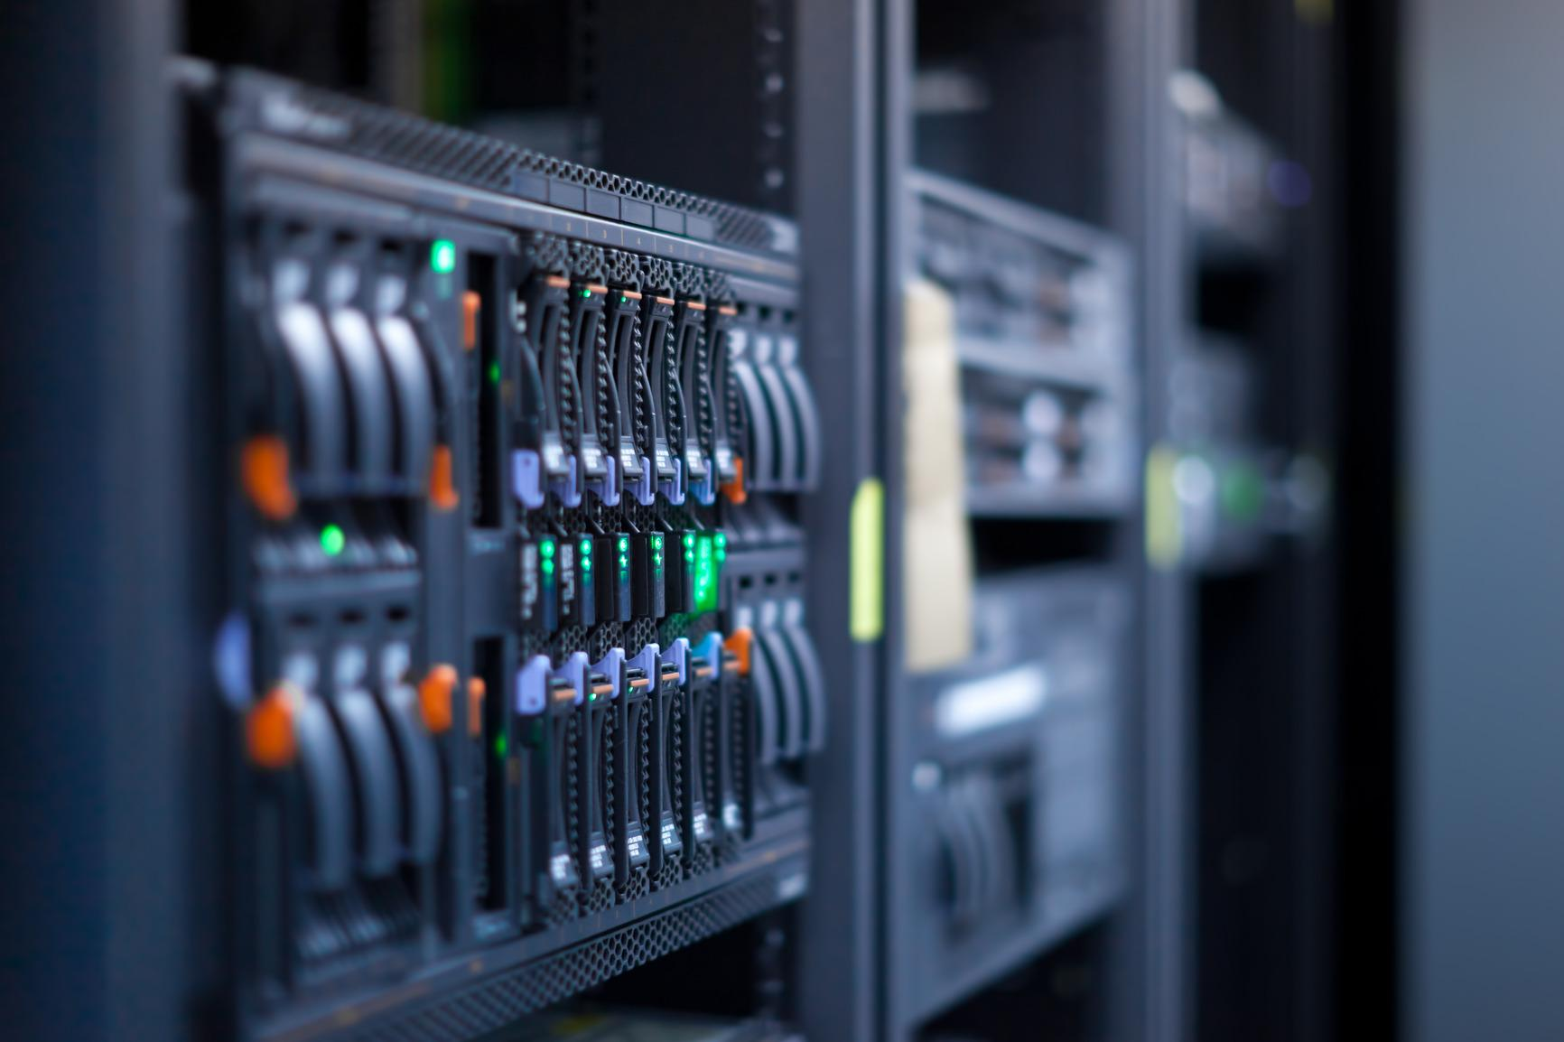
The server will reside on the Aberdeen University Campus and will provide access to the software from the entire campus.

We have outlined our recommendation for the specs of the server to the client. The decision to follow our recommendation will ultimately be one made by the client.

Testing
Before any Software can be released it must be thoroughly tested as to ensure the end user experiences the minimal number of issues. Our software is no exception.

Software
To ensure the software is the quality expected by the client we will thoroughly test the software prior to deploying the final product by using test plans we have already designed.

User inputs will be tested by using a type of testing called Black-Box testing. Black-Box tests work under the assumption that the user has no knowledge of the software's' code or how the software works.

Black-Box tests will test every scenario a user will encounter and also the usability for different age groups. These scenarios include:
- Getting documents from the CLARIN Project
- Toggle Annotations
- Attempt to access Documentation
- Access software from various different web-browsers

Hardware
Once the software has been tested we will also need to test the hardware the web-app will be stored on. We will need to run the software using the physical server we have access to and ensure it functions correctly. We will also need to ensure it can be accessed throughout the campus without any issues.

The future of the Project
Once our software has been deployed on the physical server our work on the project will be done. However, this is but a small part of a project that has spanned several years and will continue for several more.

Becuase of this it is essential that our final product is kept ‘open-ended’ and allows the LACR team to use our software to continue work on the project without any direct input from any of our team members.

To make it easier to further implement features we will ensure that:
- Easy to understand Comments are used throughout the code
- Code is neat and easy to understand
- Documentation is readily available

